**AI ASSITED CODING**

**Task 1:**

**Description:**

**Try 3 different prompts to generate a factorial function.**

**PROMPT 1:**

1. **Write a python function to find factorial of a Number**

**Code:**

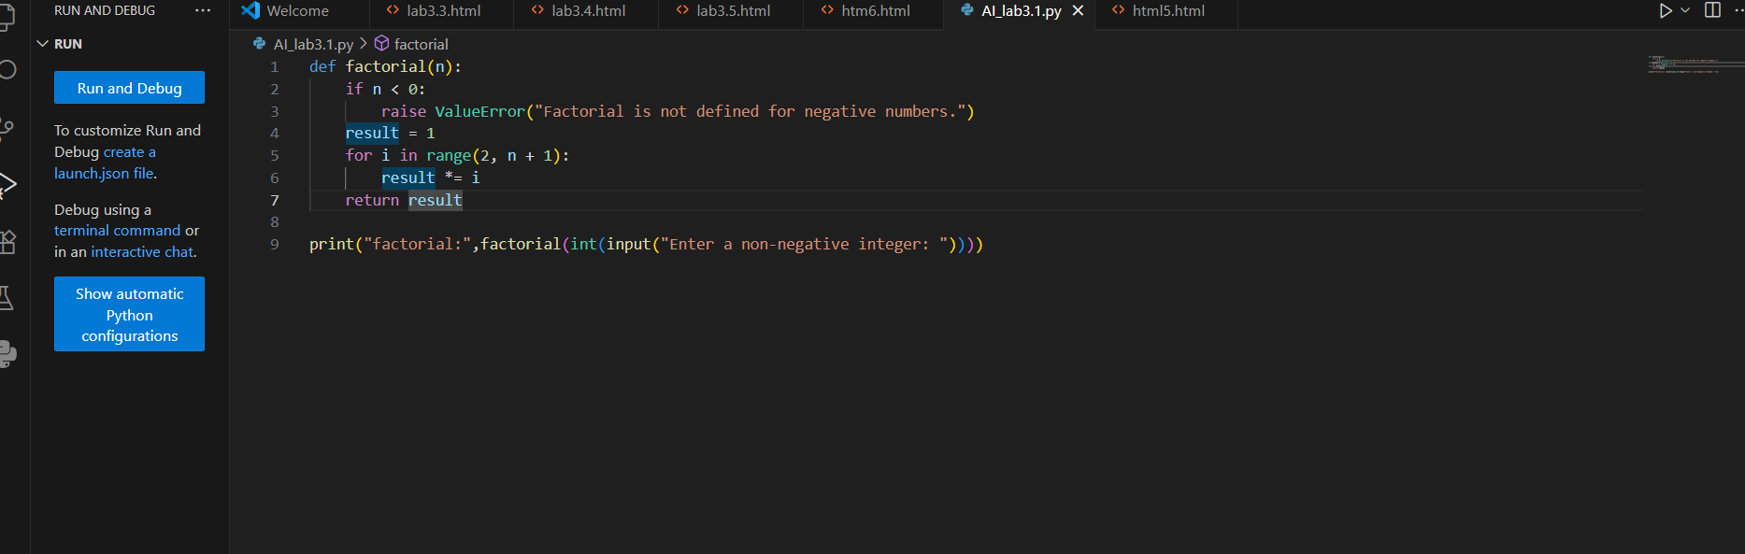

**PROMPT 2:  
write Python function for factorial**

**PROMPT 3:  
Write a python function that finds factorial of list of numbers**

**Expected Output:**

**For Prompt 1:**



**For Prompt 2:**



**For Prompt 3:**



**Comparison of AI-generated code styles**

**Explanation:**

**All the codes are given by Copilot based on the different prompts .Almost all the codes are similar.some of them are user defined and other are not user defined .**

**In Third prompt it has calculated the factorial of list of numbers**

**Observation:**

**All the outputs are as expected**

**Task 2:**

**Description:**

**Provide a clear example input-output prompt to generate a sorting function.**

**PROMPT:**

**Write a python function that sorts list of numbers where list elements are user defined**

**Code:**

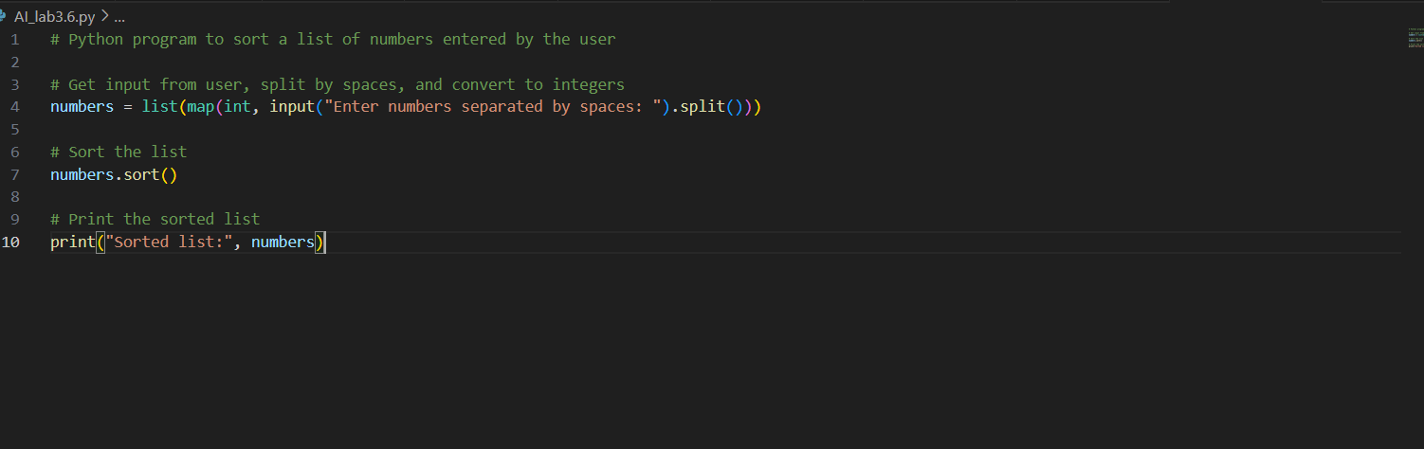

**Functional sorting code from AI**

**Output:**



**Explanation:**

**I asked Copilot to generate the code based on the prompt that I have given .It has used map method to take the inputs which are separated by spaces .**

**The numbers which are given separated by spaces are stored in list .List has a pre defined function ‘reference.sort()’**

**With the help of the function it has given the output**

**Observation:**

**As per my Observation for all the inputs outputs are expected**

**Task 3**

**Description:**

**Start with the vague prompt “Generate python code to power bill” and  
improve it step by calculate step**

**PROMPT:**

**Write a Python function to calculate an electricity bill based on total kWh used.**

**Code:**

**Output:**



**Lets improve the code with other prompt**

**Prompt 2:**

**Write a simple and efficient Python function to calculate an electricity bill based on total kWh used where kwh is user defined**

**Code:**

**Output:**



**Task 4:**

**Description:**

**Write structured comments to help AI generate two linked functions (e.g., login_user()  
and register_user()).**

**PROMPT:**

**"Write two linked Python functions: register_user() and login_user(). Use the structured comments below to guide their design and logic**

**Code:**

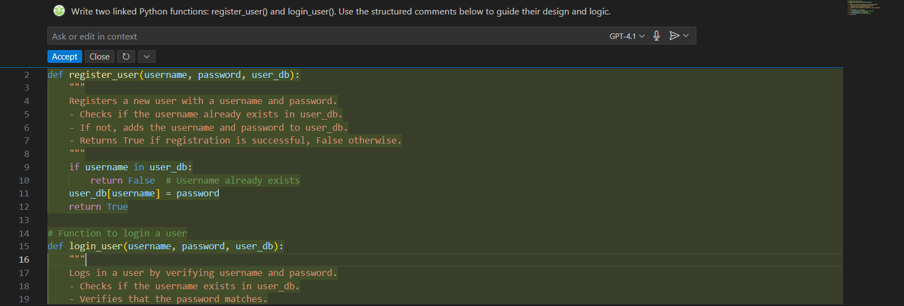

**Output:**

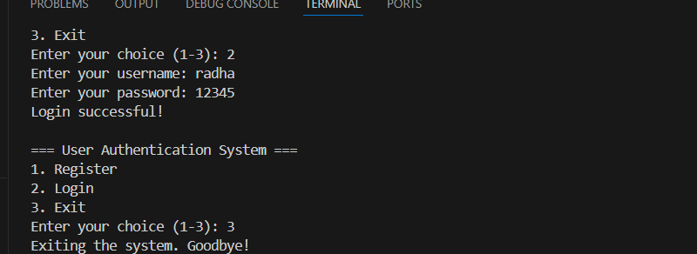

**Explanation:**

**The register_user() function adds a new user to a database (a dictionary) by checking if the username already exists—if it doesn’t, it stores the username and password. The login_user() function checks if the username exists and if the given password matches the stored one, allowing access only if both are correct. Together, these functions create a simple user authentication system with basic validation.**

**Observation:**

**All the outputs are as expected**

**Task 5:**

**Description:**

**Analyzing Prompt Specificity: Improving Temperature Conversion Function with  
Clear Instructions**

**PROMPT:**

**Write a Python function called `convert_temperature(value, from_unit, to_unit)` that converts temperatures between Celsius (C), Fahrenheit (F), and Kelvin (K). The function should:**

**Code:**

**Output:**



**Explanation:**

**Validates input units (must be 'C', 'F', or 'K').**

**Converts the input to Celsius using a to_celsius dictionary of lambda functions.**

**Then converts from Celsius to the desired target unit using a from_celsius dictionary.**

**Returns the result rounded to 2 decimal places.**

**Observation:**

**All the test cases are true as expected .**